BOOKING FORM (RSVP Before 29th September 2026)

Attendance | Member | Partner | Cost P.P. | Total
Welcome Meet and Greet  Rydges Hotel Restaurant |  |  | $45.00
Grand Installation  Rydges Hotel Function  Room |  |  | No Charge
Grand Proclamation Banquet |  |  | $90.00
Bus Trip |  |  | $55.00

Rank & Name …………………………………………………….
Jurisdiction ……………..……………………………
Conclave………………………………………...
Email …………………………………………………
Partner’s Name……………………………….…
Other Guests and Ladies………………….…….
SPECIAL DIETARY REQUIREMENTS - PLEASE ADVISE
………………………………………………
Payment by EFT to “Grand Council OSM General Account” BSB 062-644
Acc. 00902519 or by direct deposit.
(PLEASE QUOTE YOUR NAME AS REFERENCE) for:
Meet and Greet @ $45 p.p. $.................
Banquet tickets @ $90 p.p. $.................
Hunter Valley Bus Trip @ $55 p.p. $.................
Total $ …...........

Please send forms to : Mr. T. Harris
trev@shirebrewing.com
111 Garnet Road,
Gymea. NSW. 2227
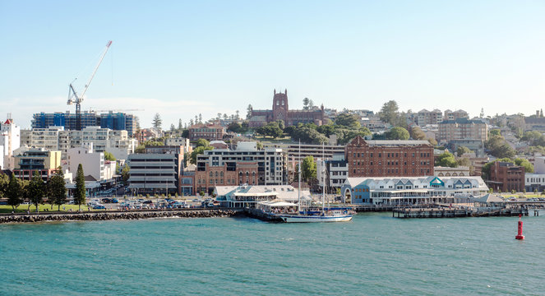
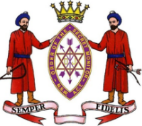
Grand Council of the
Order of the Secret Monitor
for the Sovereign State of New South Wales
and Australian Capital Territory

The Grand Supreme Ruler
Most Worthy Brother
Kevin Stewart Allen
cordially invites you to the Proclamation of
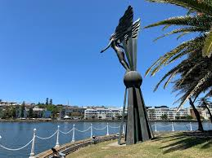
The Grand Supreme Ruler,
The Deputy Grand Supreme Ruler
and the Investiture of Officers
for 2026-27
Saturday, 10th October 2026.
Rydges Hotel Newcastle.
Wharf Rd & Merewether St, Newcastle.

Programme and Registration Form.

